Bug 1: Cart UI Not Syncing After Reset
Bug ID: SD-001
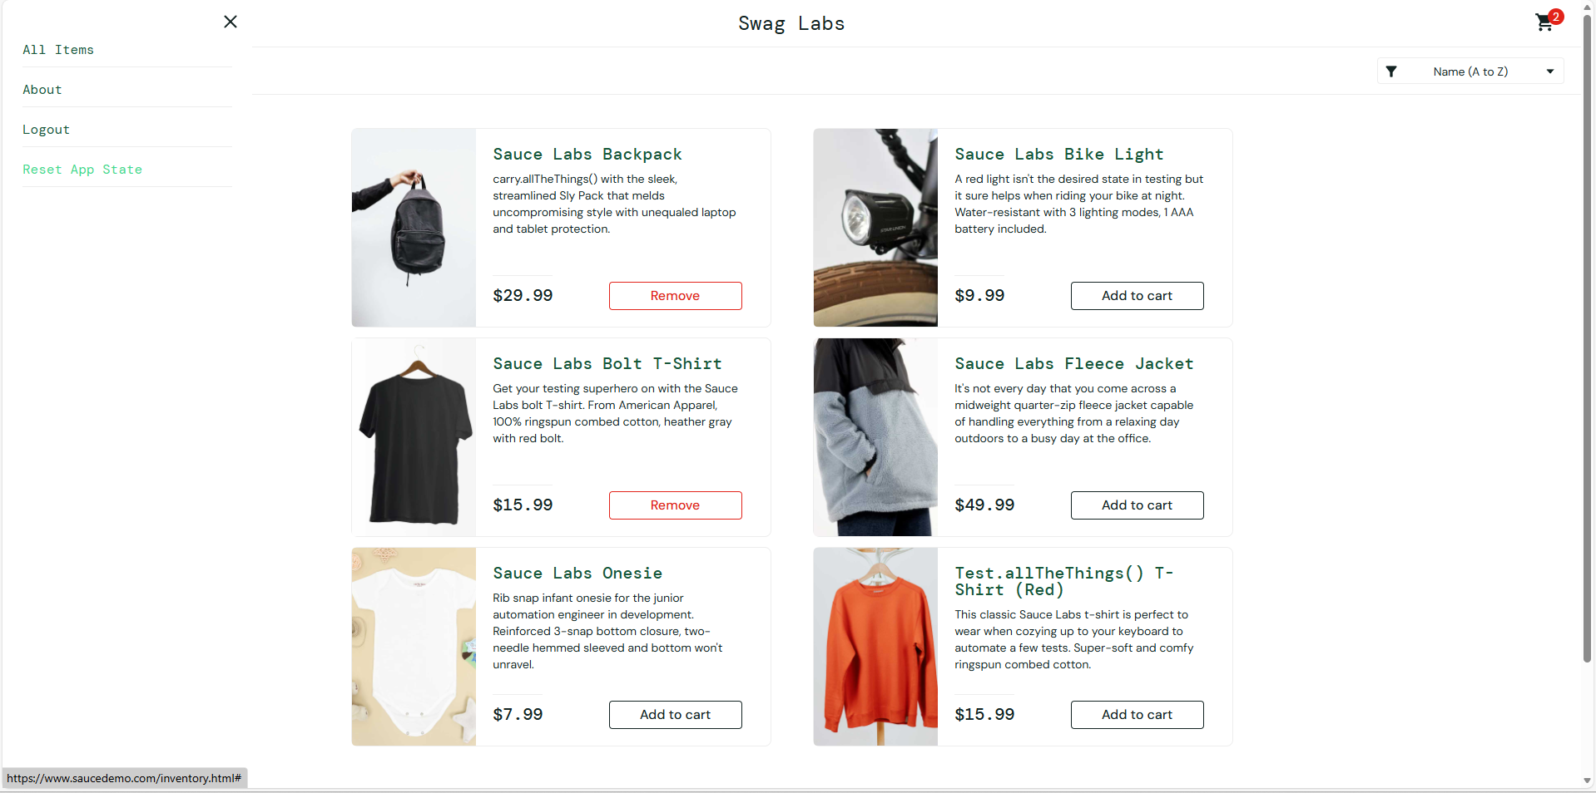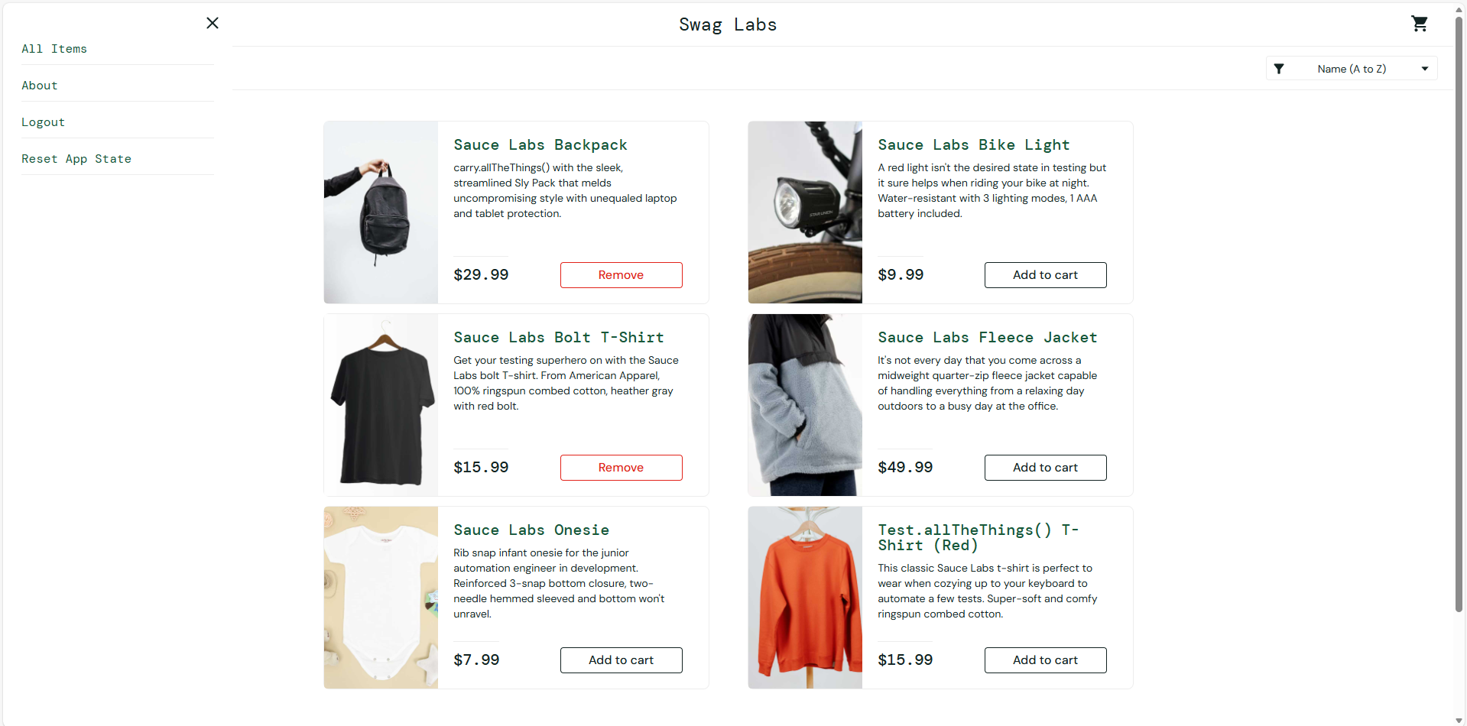

Bug 2: Checkout still proceeds without item in cart
Bug ID: SD-002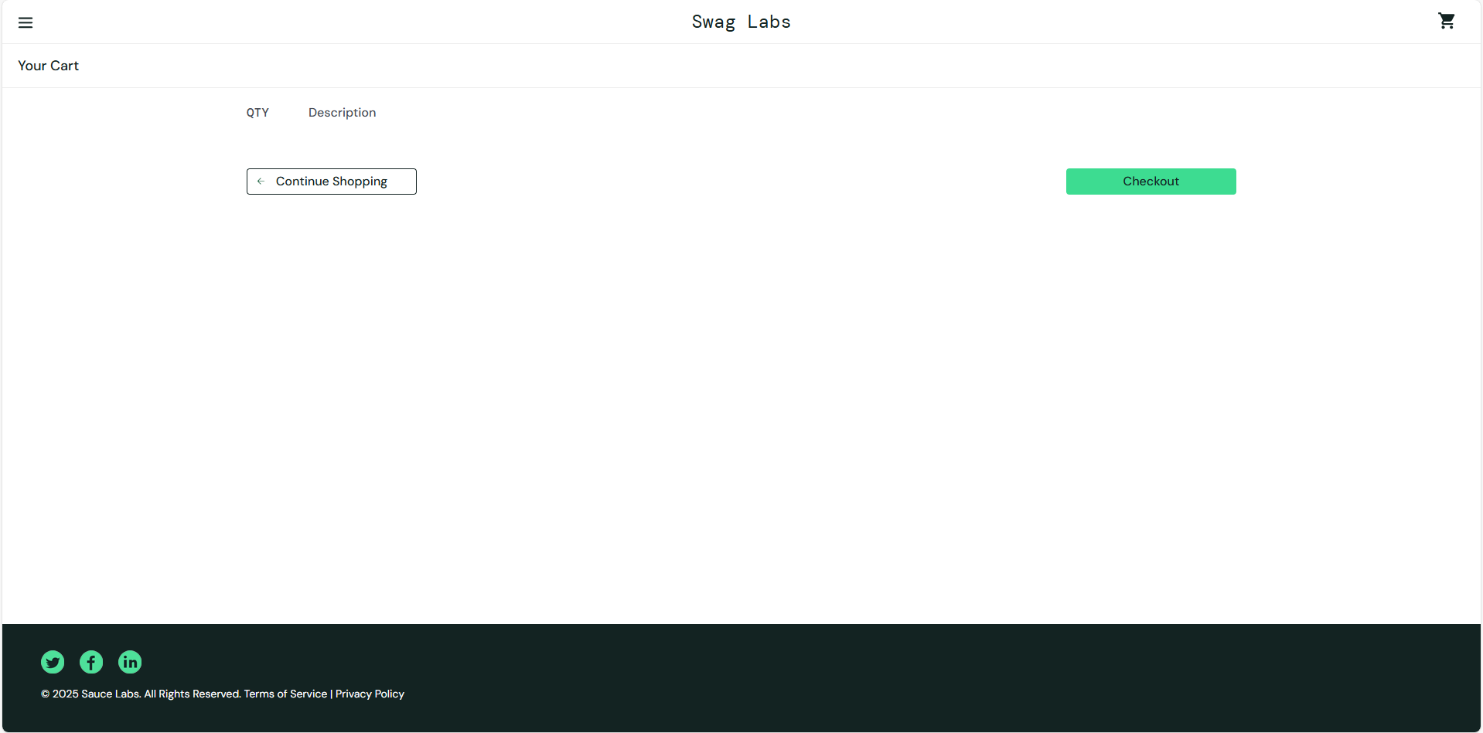

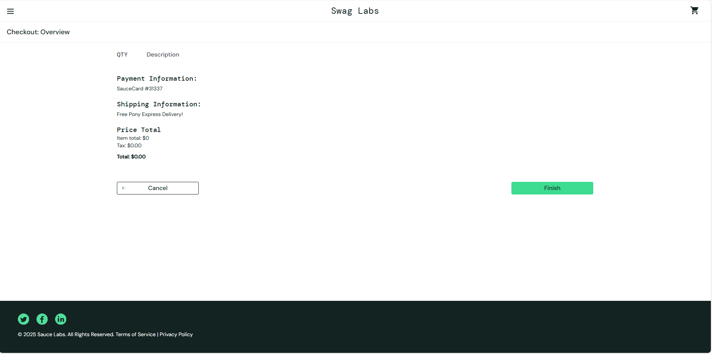
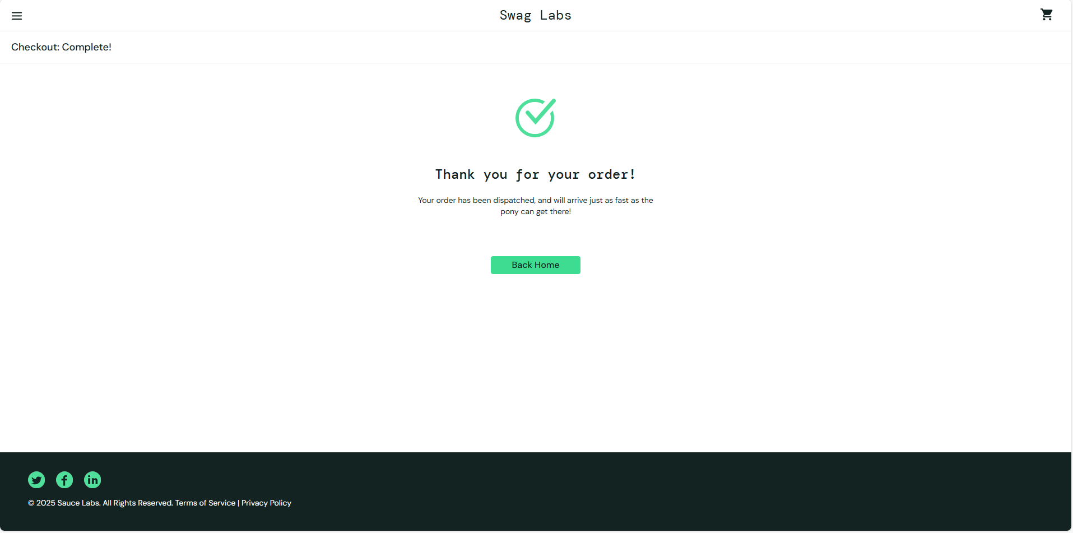

Bug 3: Unable to Edit Item Quantity in Cart
Bug ID: SD-003
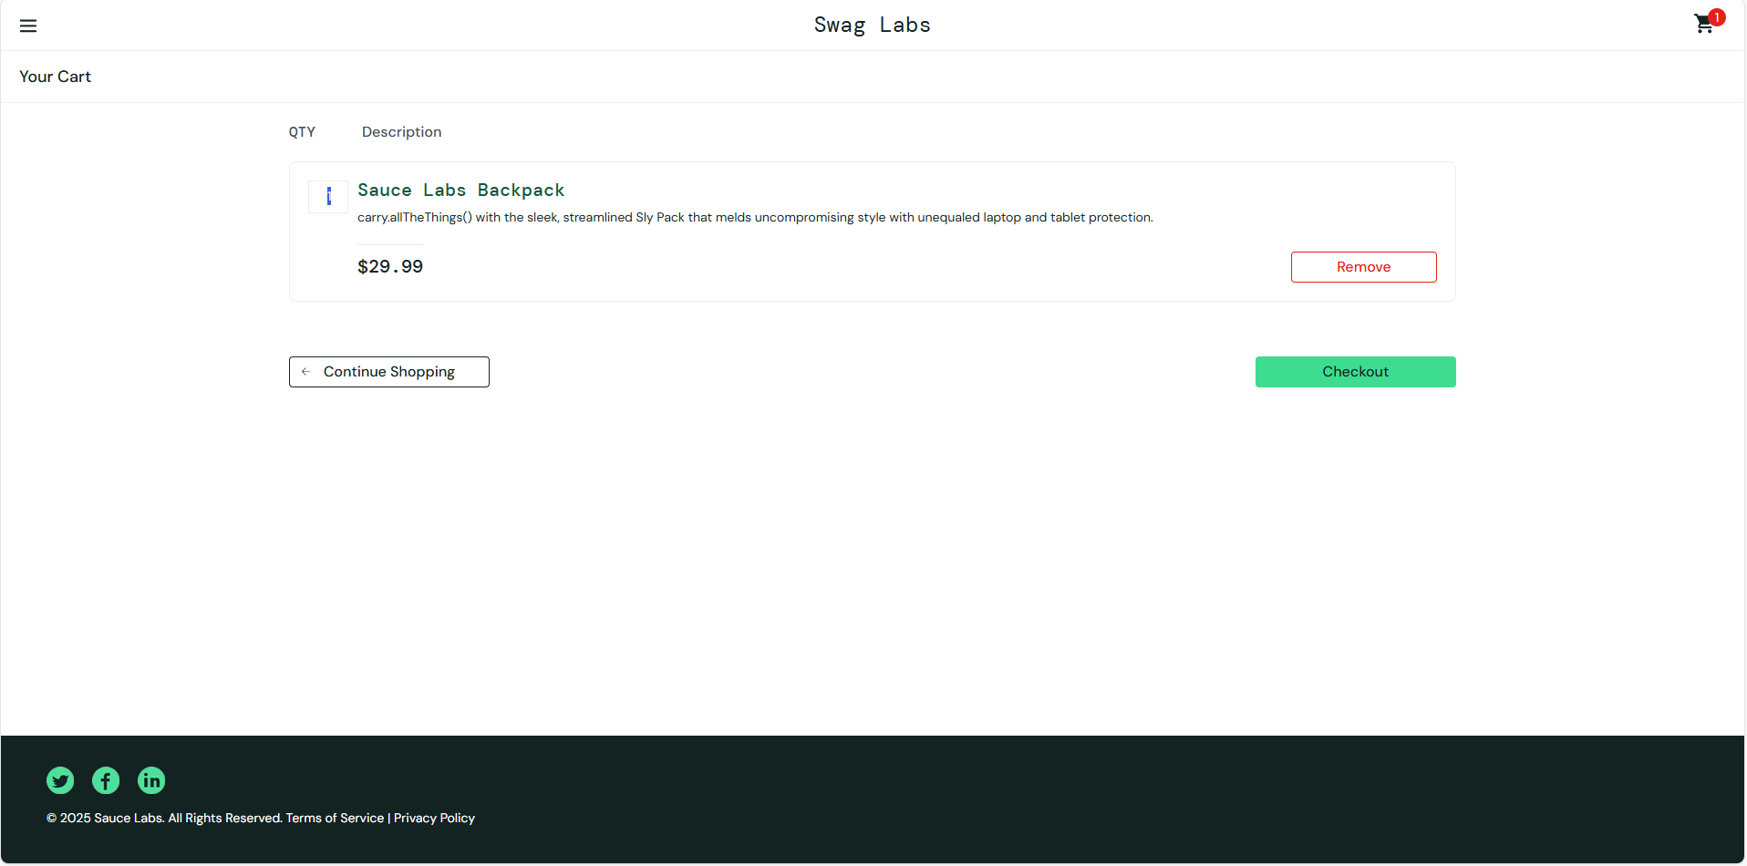

Bug 4: : First Name and Last Name Fields Accept Numbers and Special Characters
Bug ID: SD-004
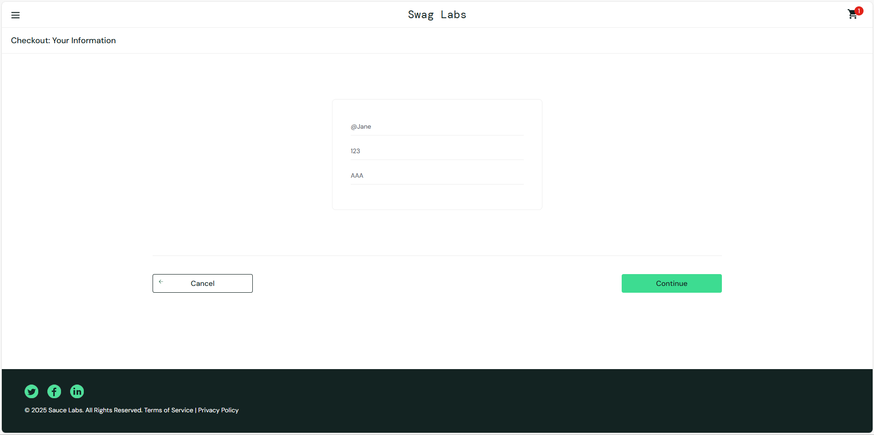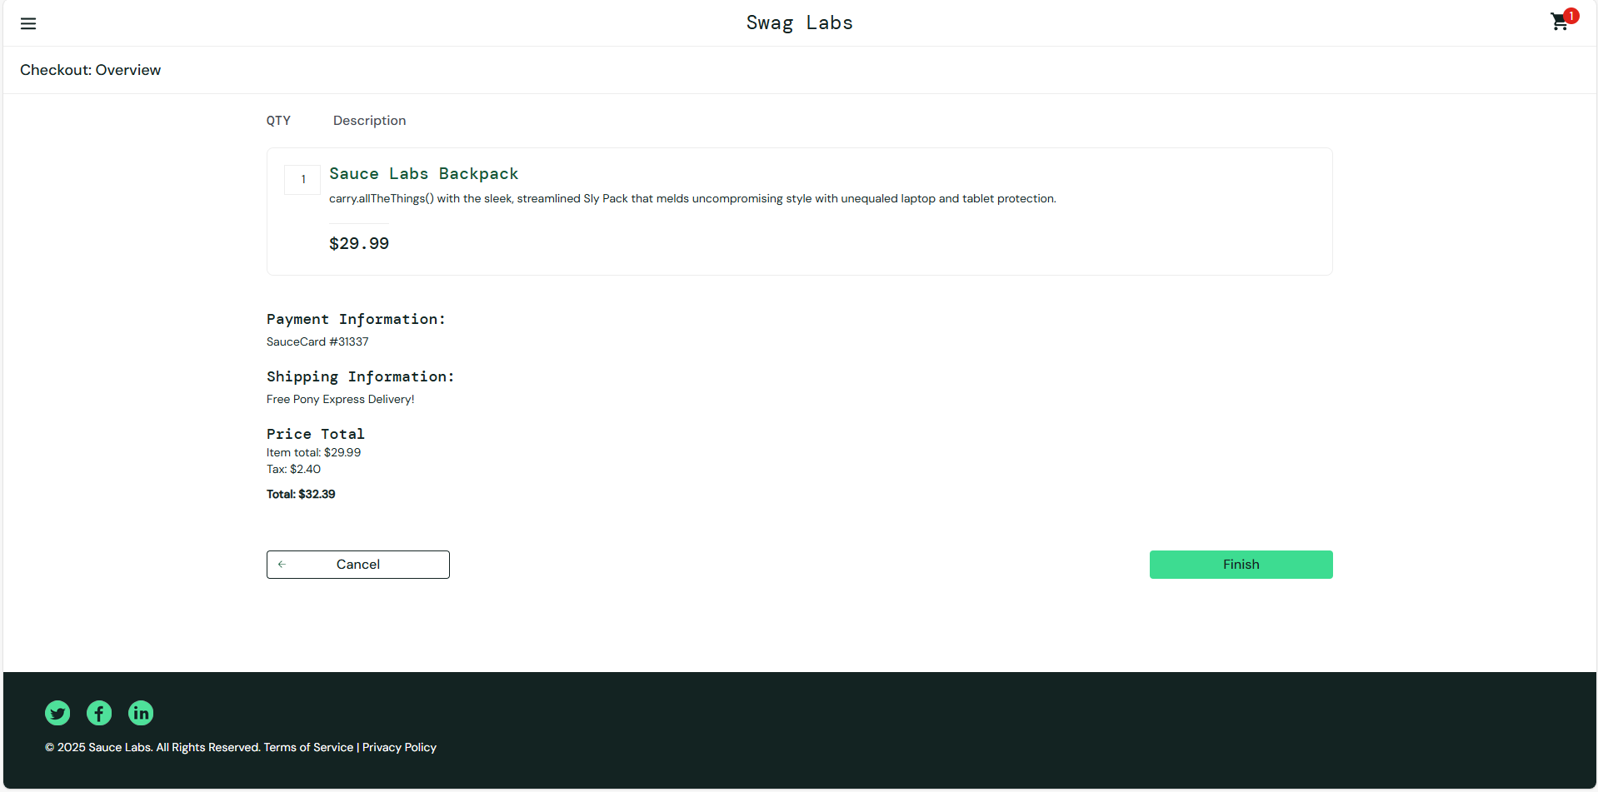

Bug 5: Zip/Postal Code field allows alphabetic characters
Bug ID: SD-004

